- Executive KPI Query
- 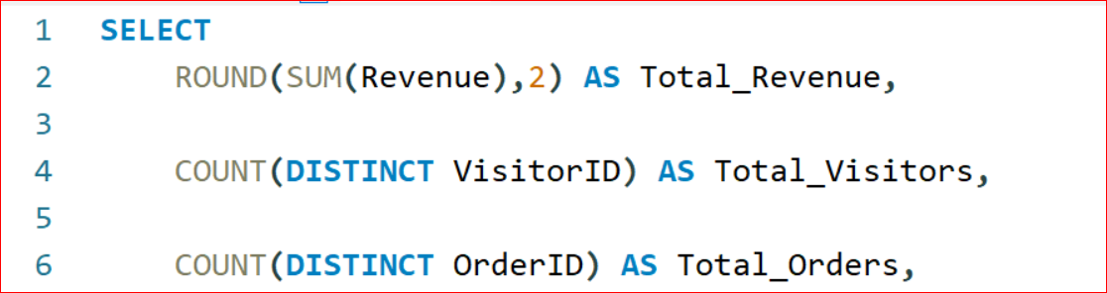
- 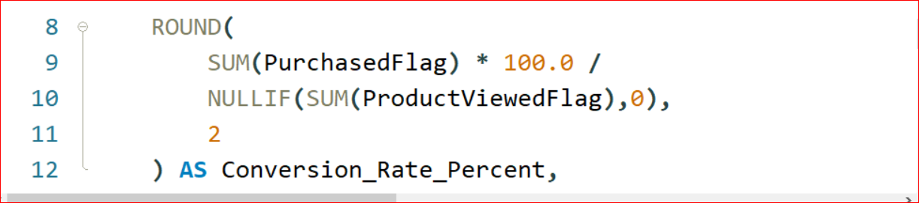
- 
- 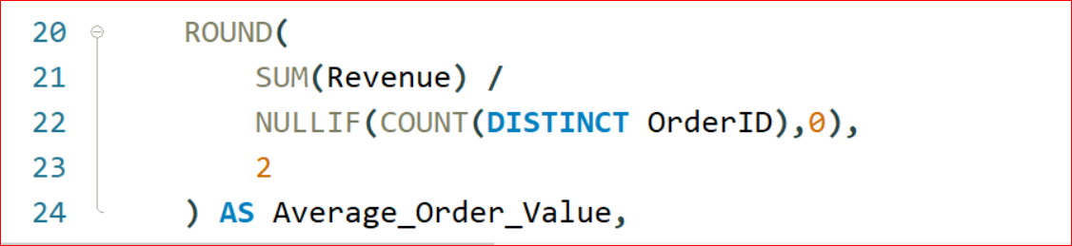
- 
- 
- 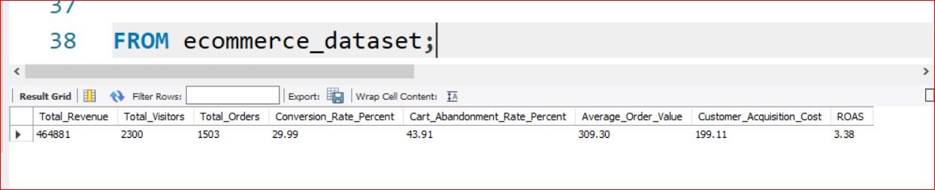

2. Chart Query — Revenue Trend Analysis
Power BI Chart
Line Chart
Axis
SessionDate
Values
Total Revenue

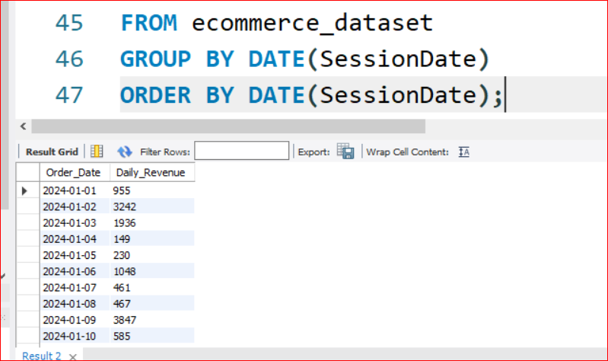
Insight
Shows revenue growth patterns, seasonal demand, and sales fluctuations.
3. Chart Query — Conversion Funnel Analysis
Power BI Chart
Funnel Chart
SELECT
'Product Viewed' AS Funnel_Stage,
SUM(ProductViewedFlag) AS Total_Customers
FROM ecommerce_dataset
UNION
SELECT
'Added To Cart',
SUM(AddedToCartFlag)
FROM ecommerce_dataset
UNION
SELECT
'Checkout Started',
SUM(CheckoutStartedFlag)
FROM ecommerce_dataset
UNION
SELECT
'Purchased',
SUM(PurchasedFlag)
FROM ecommerce_dataset;
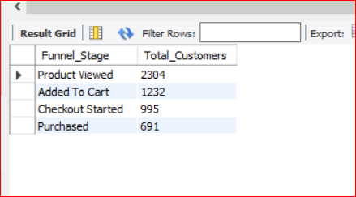
Insight
Identifies customer drop-off points during the purchase journey.
4. Chart Query — Cart Abandonment by Traffic Channel
Power BI Chart
Clustered Bar Chart
Axis
TrafficChannel
Values
Cart Abandonment Rate
SELECT
TrafficChannel,
ROUND(
SUM(CartAbandonmentFlag) * 100.0 /
NULLIF(SUM(AddedToCartFlag),0),
2
) AS Cart_Abandonment_Rate
FROM ecommerce_dataset
GROUP BY TrafficChannel
ORDER BY Cart_Abandonment_Rate DESC;
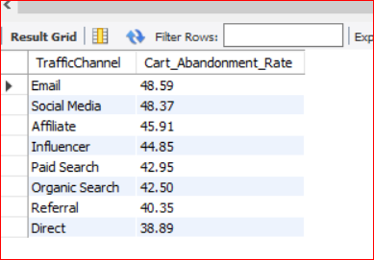
Insight
Reveals low-quality traffic channels causing purchase abandonment.

5. Chart Query — Marketing ROI by Channel
Power BI Chart
Clustered Column Chart
SELECT
TrafficChannel,
ROUND(SUM(Revenue),2) AS Revenue,
ROUND(SUM(MarketingCost),2) AS Marketing_Cost,
ROUND(
SUM(Revenue) /
NULLIF(SUM(MarketingCost),0),
2
) AS ROAS
FROM ecommerce_dataset
GROUP BY TrafficChannel
ORDER BY Revenue DESC;

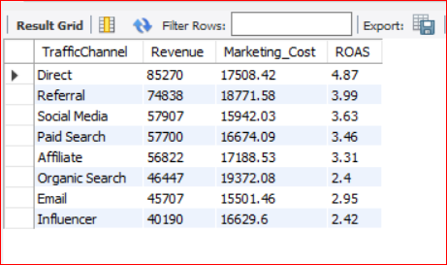
Insight
Compares revenue generation vs marketing spend effectiveness.

6. Chart Query — Device Conversion Performance
Power BI Chart
Donut Chart
SELECT
DeviceType,
ROUND(
SUM(PurchasedFlag) * 100.0 /
NULLIF(SUM(ProductViewedFlag),0),
2
) AS Conversion_Rate
FROM ecommerce_dataset
GROUP BY DeviceType
ORDER BY Conversion_Rate DESC;

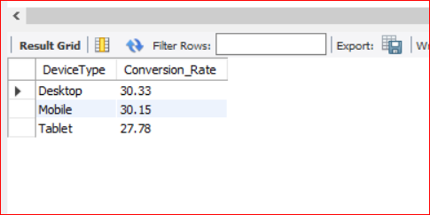
Insight
Shows which device drives highest purchase completion.

7. Chart Query — Customer Segment Revenue Contribution
Power BI Chart
Treemap
SELECT
CustomerSegment,
ROUND(SUM(Revenue),2) AS Revenue
FROM ecommerce_dataset
GROUP BY CustomerSegment
ORDER BY Revenue DESC;
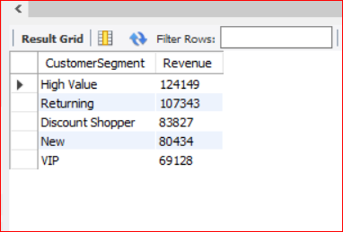
Insight
Highlights the most profitable customer segments.

8. Chart Query — Regional Marketing Performance
Power BI Chart
Map Chart
SELECT
Region,
ROUND(SUM(Revenue),2) AS Revenue,
ROUND(
SUM(Revenue) /
NULLIF(SUM(MarketingCost),0),
2
) AS ROAS
FROM ecommerce_dataset
GROUP BY Region
ORDER BY Revenue DESC;

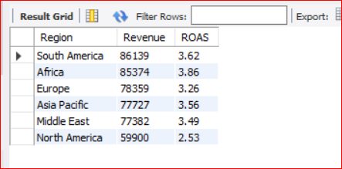
Insight
Shows geographic sales and marketing performance.

9. Chart Query — Revenue by Marketing Channel
Power BI Chart
Stacked Bar Chart
SELECT
TrafficChannel,
ROUND(SUM(Revenue),2) AS Revenue
FROM ecommerce_dataset
GROUP BY TrafficChannel
ORDER BY Revenue DESC;
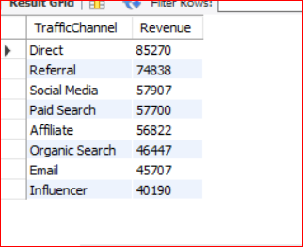
Insight
Identifies strongest acquisition channels.

10. Chart Query — Customer Engagement Analysis
Power BI Chart
Scatter Chart
X-Axis
Pages Viewed
Y-Axis
Revenue
SELECT
PagesViewed,
ROUND(AVG(Revenue),2) AS Avg_Revenue
FROM ecommerce_dataset
GROUP BY PagesViewed
ORDER BY PagesViewed;
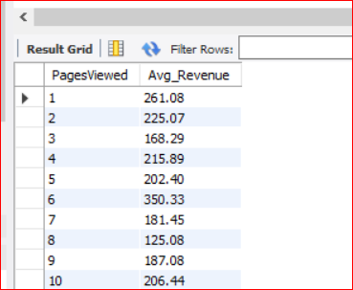
Insight
Shows relationship between engagement and spending.

11. Advanced KPI Query — Monthly Performance Dashboard
SELECT
YEAR(SessionDate) AS Year,
MONTH(SessionDate) AS Month,
ROUND(SUM(Revenue),2) AS Revenue,
COUNT(DISTINCT VisitorID) AS Visitors,
COUNT(DISTINCT OrderID) AS Orders,
ROUND(
SUM(PurchasedFlag) * 100.0 /
NULLIF(SUM(ProductViewedFlag),0),
2
) AS Conversion_Rate,
ROUND(
SUM(CartAbandonmentFlag) * 100.0 /
NULLIF(SUM(AddedToCartFlag),0),
2
) AS Cart_Abandonment_Rate,
ROUND(
SUM(Revenue) /
NULLIF(SUM(MarketingCost),0),
2
) AS ROAS
FROM ecommerce_dataset
GROUP BY
YEAR(SessionDate),
MONTH(SessionDate)
ORDER BY Year, Month;

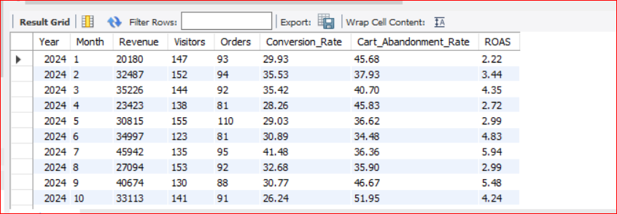
Insight
Tracks monthly performance trends for executives.

